**Phase – II**

**Practice Project – III**

**Add New Product**

**Sai Krishna Rajagopal**

**22-03-2022**

**GITHUB Repository URL:** [**https://github.com/SaiKrishna6699/JavaFSDTraining.git**](https://github.com/SaiKrishna6699/JavaFSDTraining.git)

**Technical Summary:**

1. **JSP**
2. **Java EE**
3. **Eclipse**
4. **Web Browser (Chrome)**
5. **MySQL**
6. **Tomcat 8.5**
7. **Git**
8. **JSP:**

JSP file named index.jsp is used to imbed html page with minimal CSS is created, which consists of a HTML Form takes input for the Adding Product.

1. **Java EE:**

The Adding A new product was developed in Java Enterprise Edition (Java EE) using the concept of Servlets.

The Application is fully Functional and Working Perfectly with No Exceptions.

Short Summary of Code:

* In this Application there are two Java Servlets for full functional working of the application.
* Product Controller is the Java Servlet Programs created for controlling database.
* Save Product is a java Servlet created to Add Product into the database.
* Product Details:
  + In the Product Controller Servlet, It works on the response from the Index JSP page. The doGet method is used to request and take response from the HTML Page using Http Servlet package.
  + Database connection is imported form Product DOA java class using inheritance concept.
  + String Name and int Pid and Price are created to store the parameters from the HTML page for Product id, Name, Price.
  + Later takes input form the Form and Adds the details into DB.
  + If it is valid then the session gets redirected to Dashboard servlet.
  + Else if not valid it will generate an error message in the Index jsp.

1. **Eclipse:**

Eclipse is the IDE used to Write the code. It is a very programmer friendly and easy to use application.

1. **Tomcat 8.5:**

Apache Tomcat is a webserver which is used to host web apps locally in the system. In this project Tomcat 8.5 is used to host the Servlet application. Tomcat 8.5 supports Java 7 and other latest versions of the Java EE.

1. **MySql:**

MySQL is an open-source relational database management system. It is structured query language created Oracle Corporation. Here MySql is used to connect database to eclipse using mysqlConnector jar file.

1. **Git & GitHub:**
   1. Git is the version control system used to store the data in a remote Repository.
   2. GitHub is the remote data base contains repository which is used to store the data.

Git Commands used:

$git init

$git remote -v

$git add .

$git commit -m “Adding PP3”

$git branch -M master

$git push -u origin master

1. Screenshots:

Output:

Index Jsp:

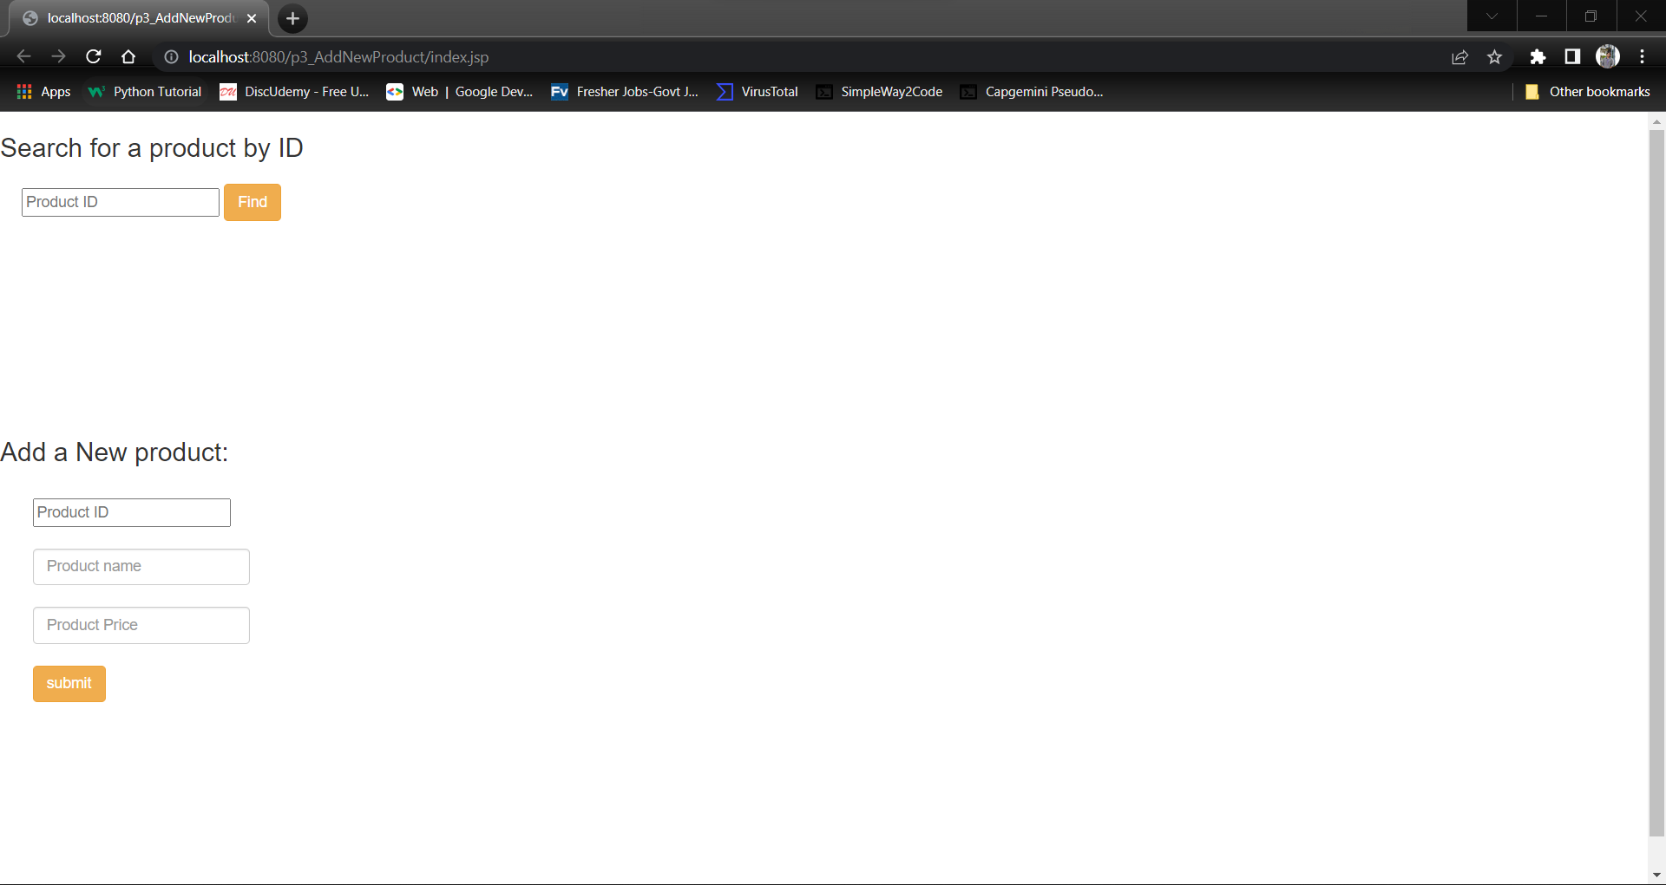

Output1:

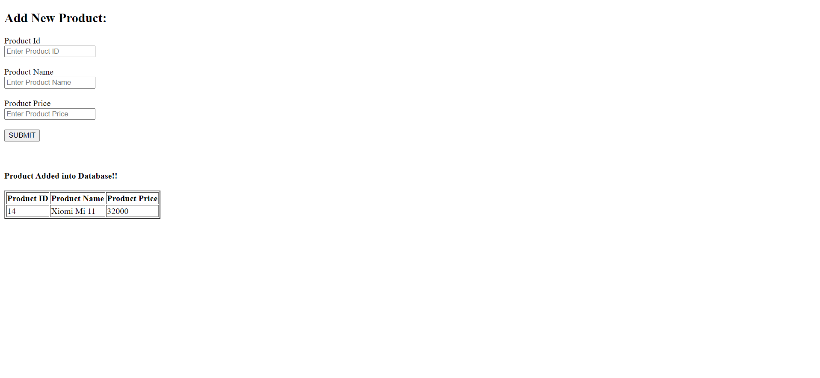

Output 2:

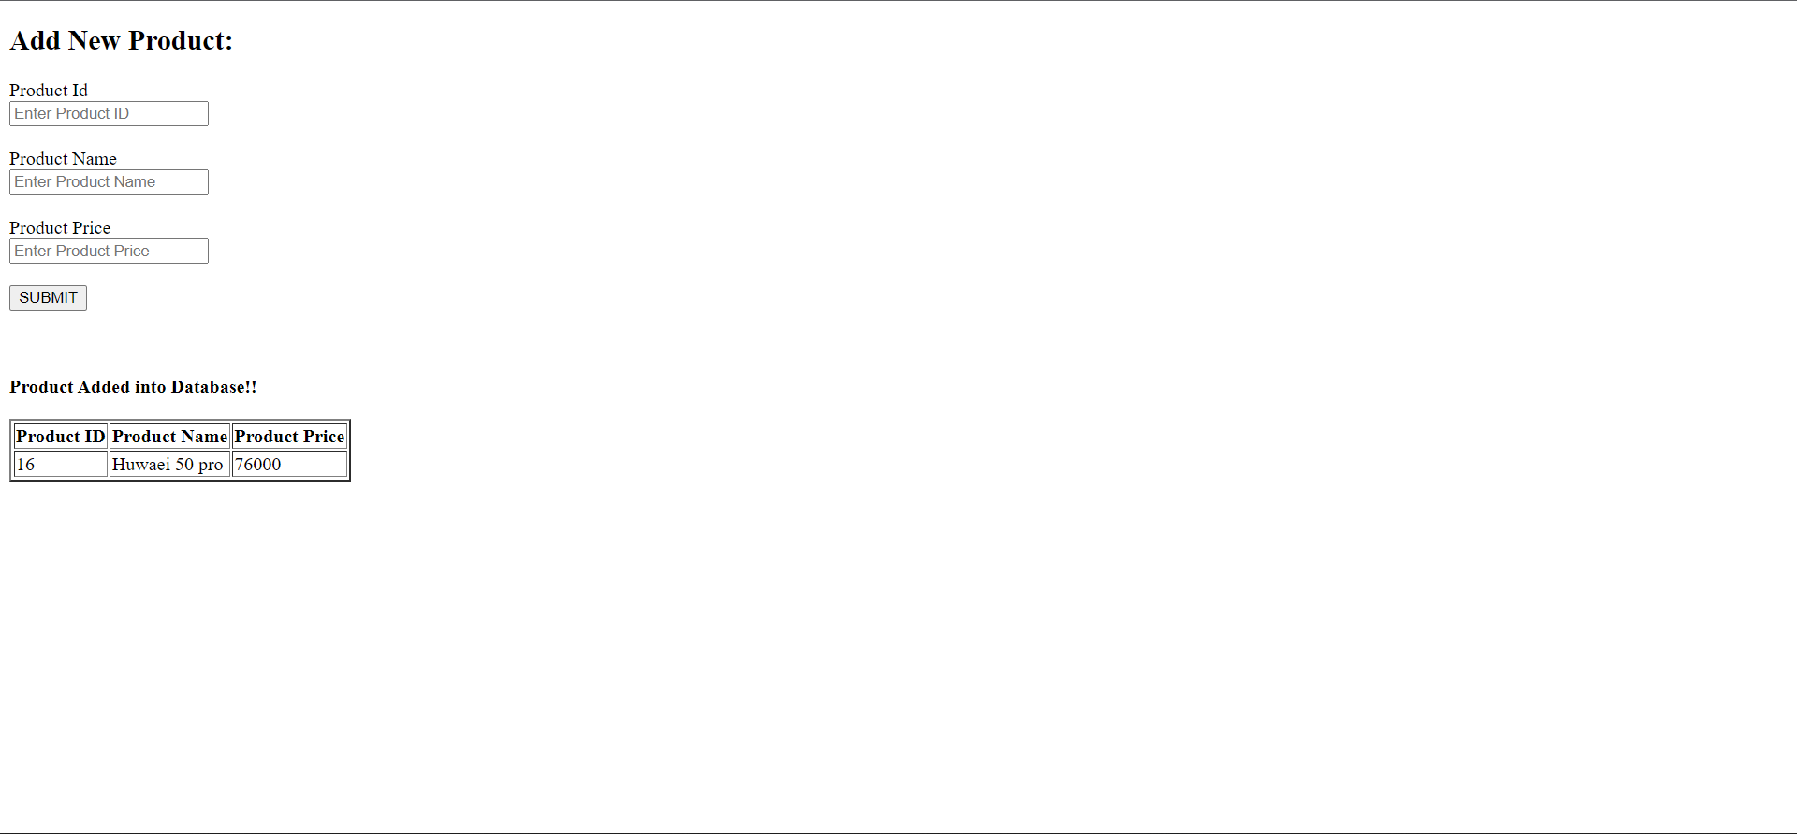

Git:

